**How to Access the website**

Follow the instructions below using the sample link provided: <https://35.198.233.36:8090/api/smartrpd/case/get/797>

**Step 1: Paste the Link in the Search Bar**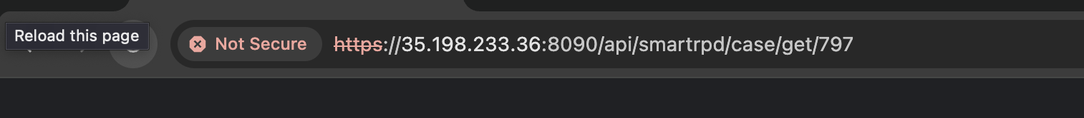

**Step 2: Click on "Advance"**

**Step 4: Paste the Link for the Web-RPD in search bar**

**Link:** <https://wyl-asg.github.io/finale/?id=OAJBLhkNOQoOdFADDmMBGQ>

